Name: Class:

Task 1 Run Length Encoding
The black and white image below contains 64 pixels.
1. How many bits would be used to represent the image?

2. The binary code for the first row would be 1111 1110 assuming white = 1 and black = 0.
How would the row be represented using Run Length Encoding?

3. Complete the pixel grid below using the following RLE frequency/data pairs.
21 10 21
21 20 11
50
21 20 11
21 10 21

Task 2
- The file RiverBMP is 696 kilobytes in size. Make use of an image editing program to investigate the effect of changing the resolution and colour depth of the image and complete the table below.
If you are in Windows, Microsoft Paint will be sufficient for this investigation. The filetypes to save as are shown here:
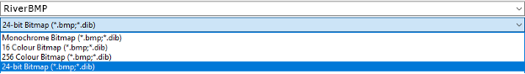
The dialogue box for changing the size is as follows:
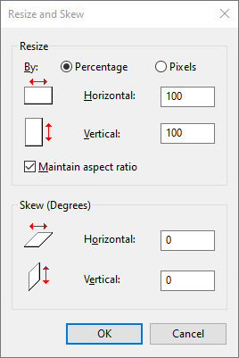

File name to save as and file properties | File size | Insert the image and describe the difference the changes have made
RiverBMP.bmp  650 × 365 | 696 kB | A good high quality image is seen  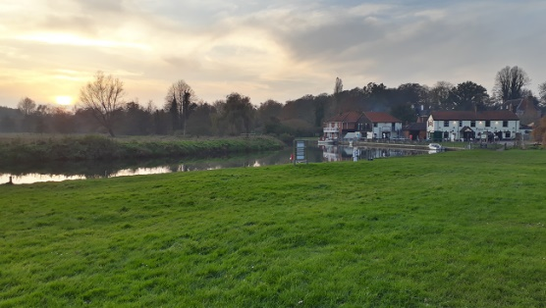
RiverBMP256.bmp
RiverBMP16.bmp
BeachBMP50percent resolution.bmp

- Explain how the file size changes when the resolution (image dimensions) or colour depth are changed.

Task 3
A piece of music is 39.79MB recorded at CD quality.
When compressed using the MP3 compression format, this becomes 3.6MB.
- Calculate the Internet download time for each file using a 24Mbps home connection and a 3G mobile connection. Use this website to help you. www.download-time.com
Quality | Download time at 24Mbps | Download time over 3G
CD
MP3
2. Give two advantages of using a compressed music format for streaming music over an Internet data connection.

Task 4
For each of the scenarios below, suggest whether lossy or lossless compression should be used.
Use | Lossy / Lossless |  | Reason
A music track
A text document
A video clip
A web image
A software application
A database

